***HR ANALYTICS PROJECT- UNDERSTANDING THE ATTRITION IN HR***

Name – CHAITALI MOHIT NAKADE



My name is Chaitali Nakade and in this blog-post I will give the complete information about model building of “Attrition in HR” with the help of HR analytics.

Every year a lot of companies hire a number of employees. The companies invest time and money in training those employees, not just this but there are training programs within the companies for their existing employees as well. The aim of these programs is to increase the effectiveness of their employees but due to Attrition in human resources refers to the gradual loss of employees’ overtime. In general, relatively high attrition is problematic for companies.

**PROBLEM DEFINITION: -**

How does Attrition affect companies? and how does HR Analytics help in analysing attrition? We will discuss the first question here and for the second question, we will write the code and try to understand the process step by step.

**Attrition affecting Companies:**

A major problem in high employee attrition is its cost to an organization. Job postings, hiring processes, paperwork, and new hire training are some of the common expenses of losing employees and replacing them. Additionally, regular employee turnover prohibits your organization from increasing its collective knowledge base and

experience over time. This is especially concerning if your business is customer-facing, as customers often prefer to interact with familiar people. Errors and issues are more likely if you constantly have new workers.



**DATA ANALYSIS: -**

**Importing the Libraries:**

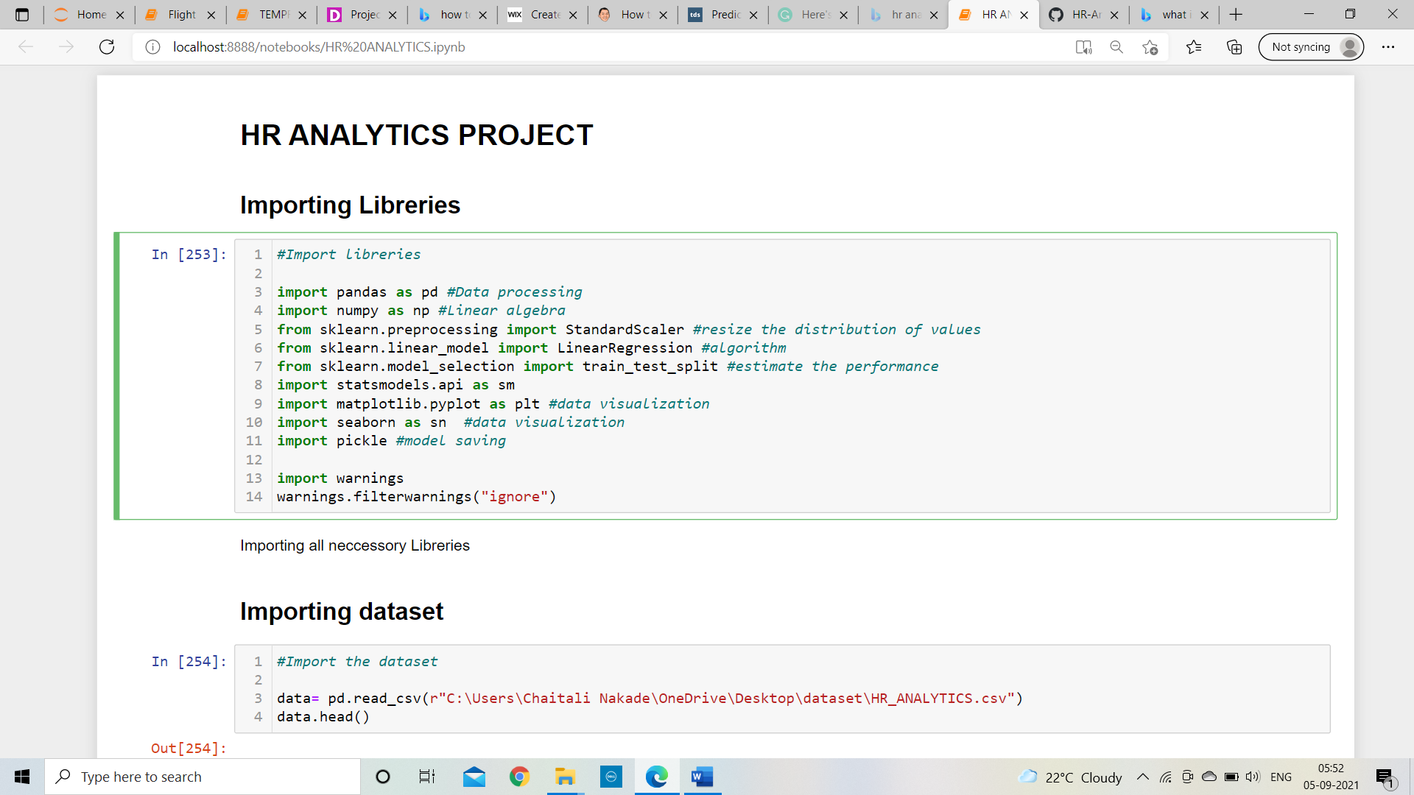

All these libraries are used for model building and data processing. Use of all libraries are mentioned over there

**Getting the Dataset:**



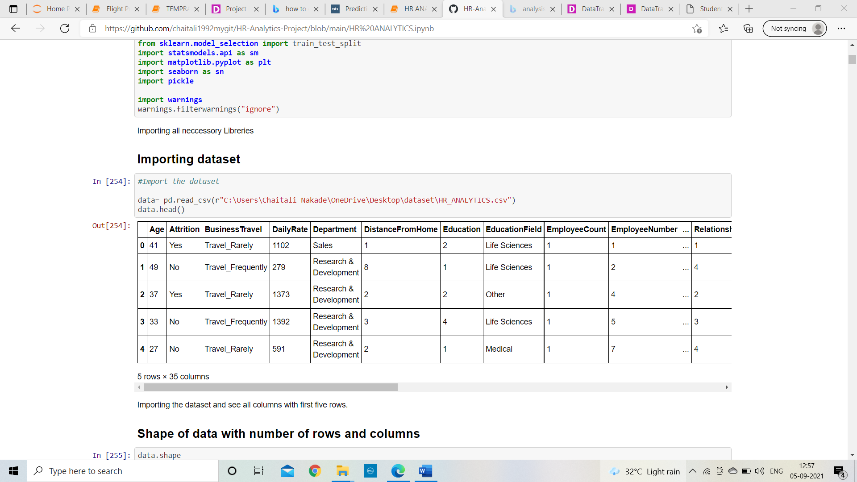

The complete dataset is imported in variable name data and we can see there are some columns are need to alter them into numeric data because machine learning will not work with object data type but before that need to analyse the data.

**Data Exploration:**

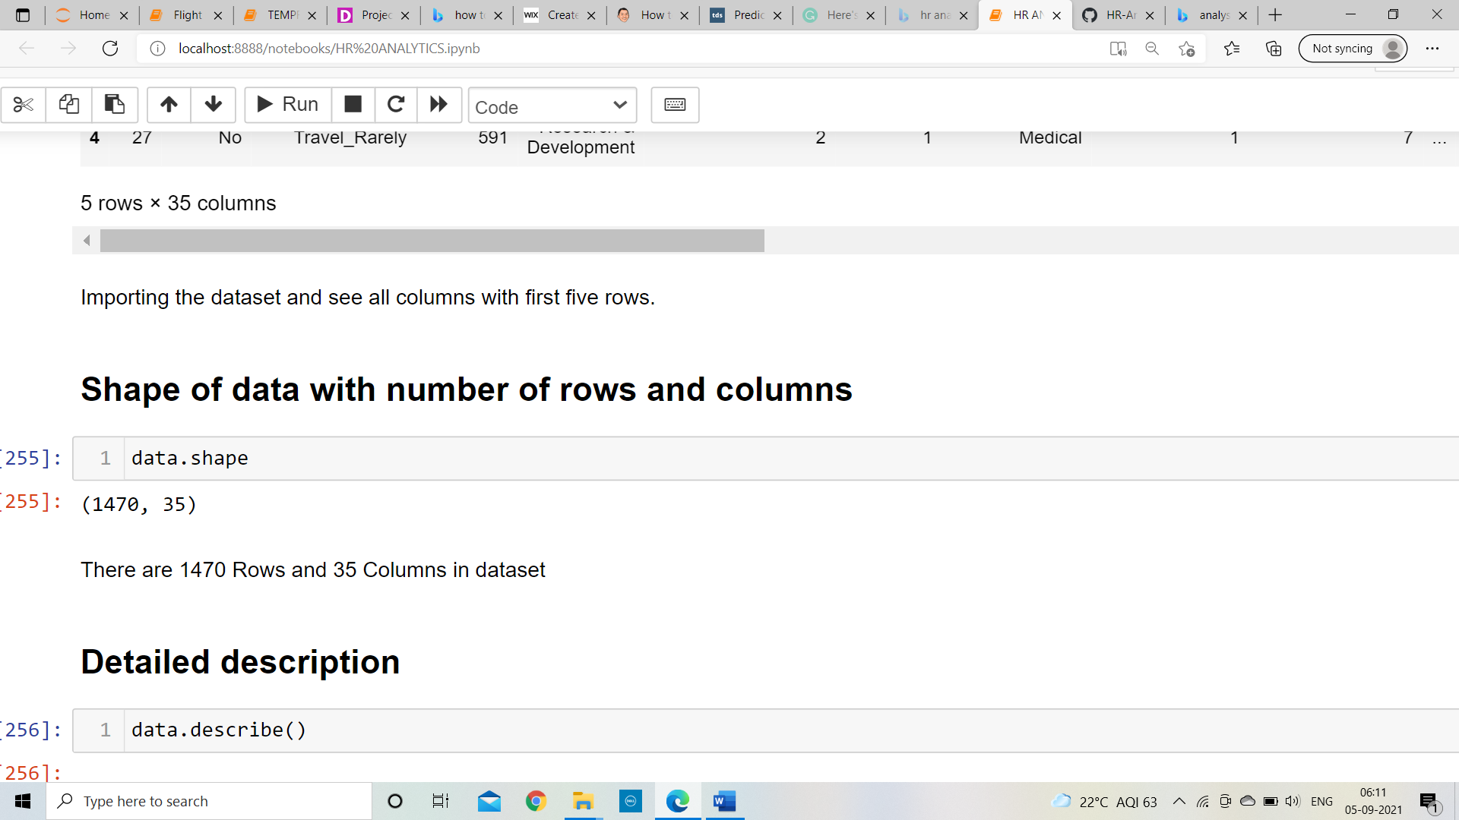

There are 1470 rows and 35 columns are present in dataset.

**Information of Dataset:**

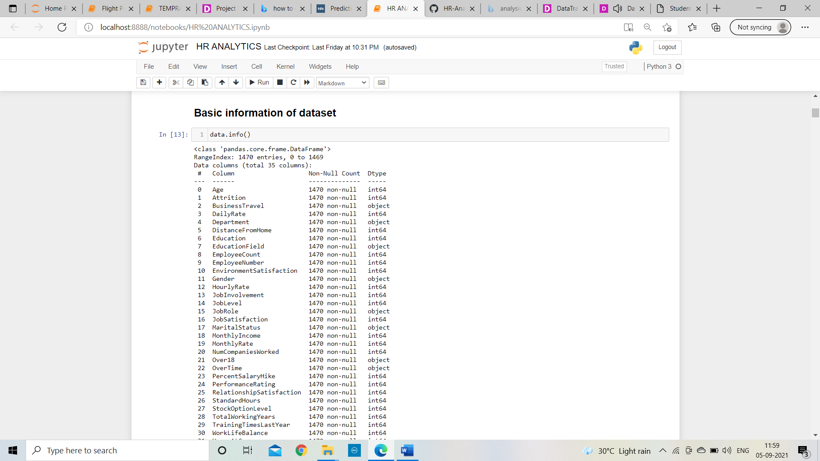

**Output:**

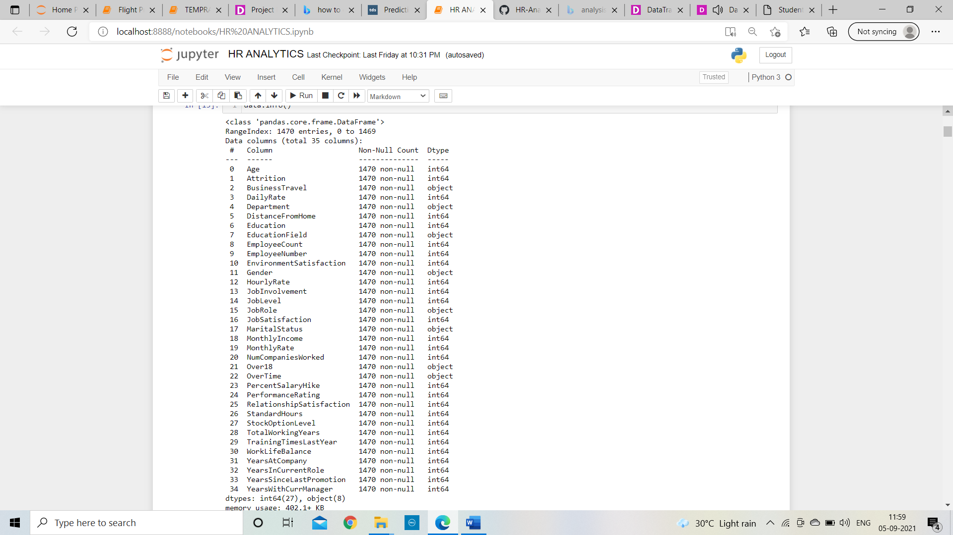

* As shown in output there is no null value values in whole dataset.

**The dataset has 1470 rows, 34 input/independent variables and one target variable i.e., Attrition**. 27 of them are integer datatype and 8 are objects. Target variable is also had object datatype.

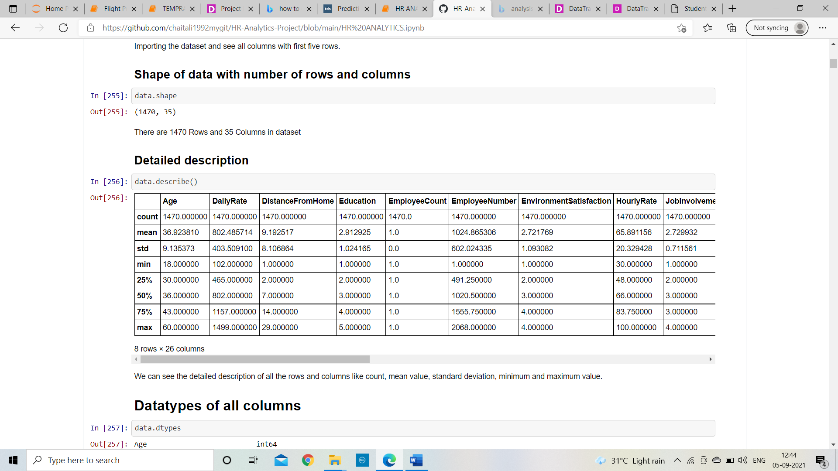



Above we can see that detailed description of rows and columns like count, mean value, standard deviation, minimum and maximum value and quantiles with 25%, 50% and 75%. Here we can see few columns of dataset.

**EXPLORATORY DATA ANALYSIS(EDA): - ss**

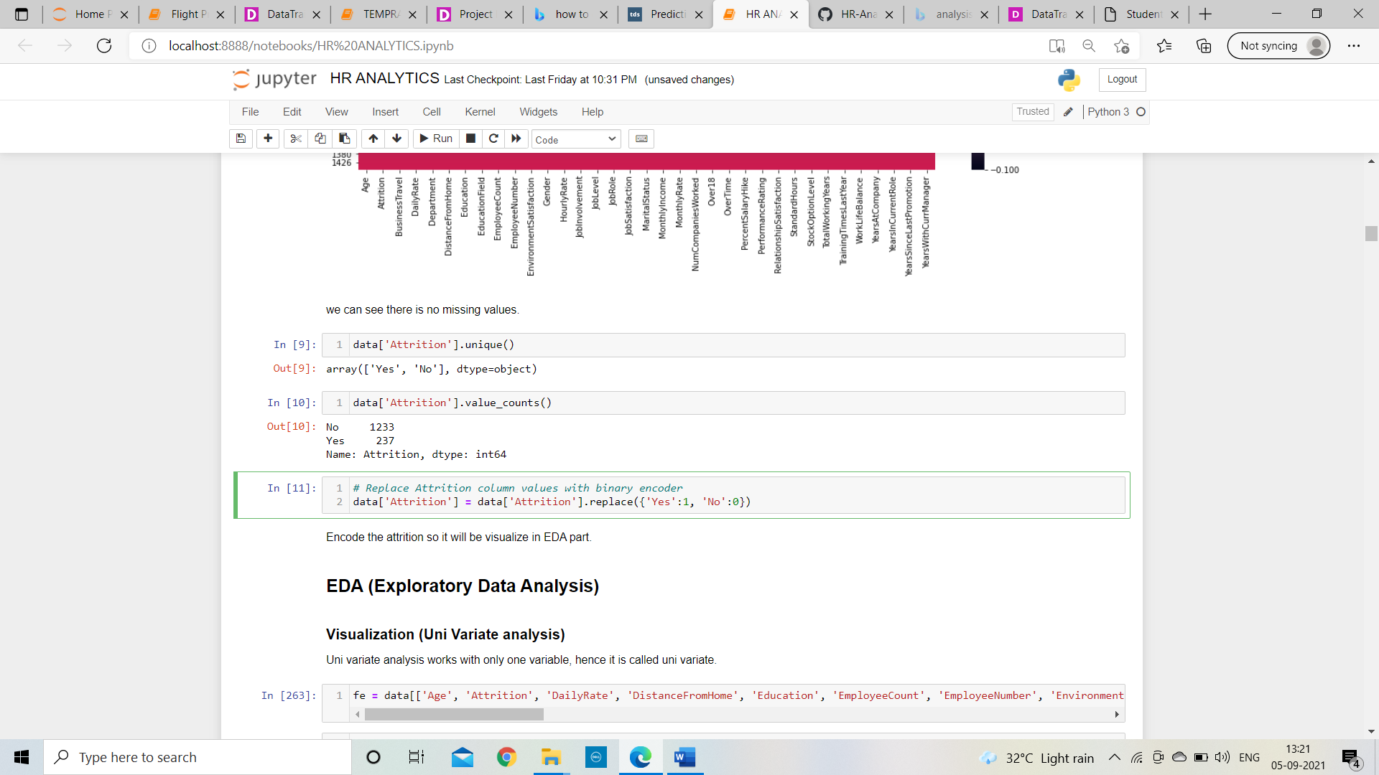

After encoding attrition column with binary encoder, we can find that yes value will become 1 and no will become 0.

**Data Visualization:**

A countplot basically**counts the classes and returns a quantity of their occurrences.** In above we can see,

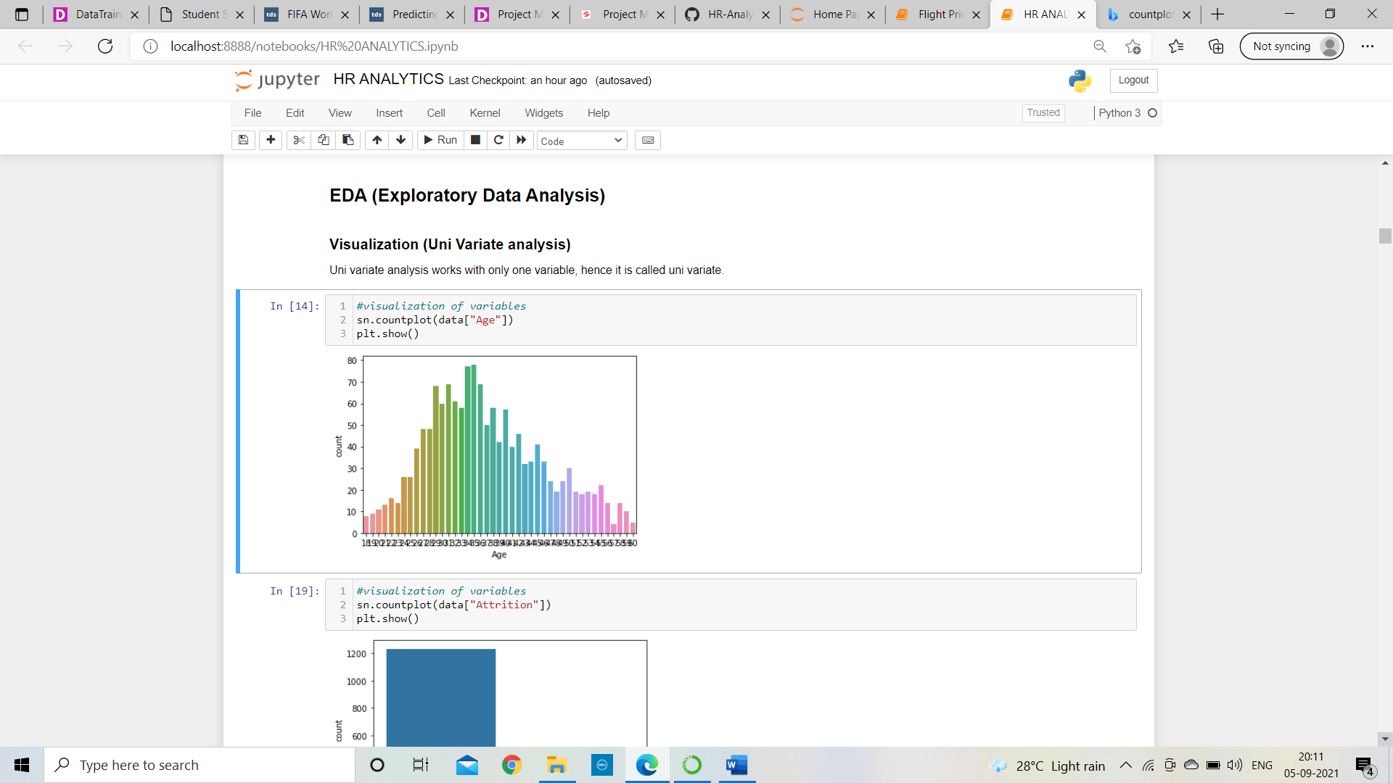

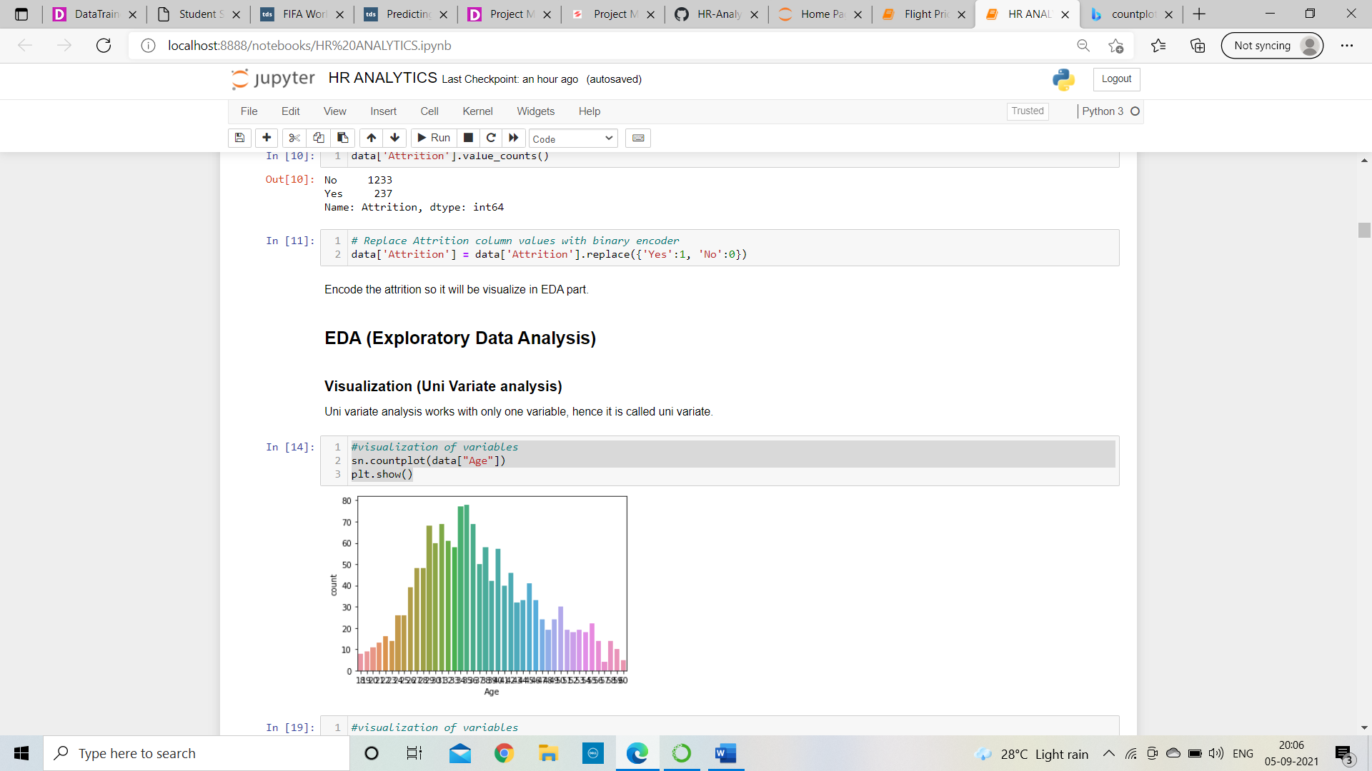

The majority of the Employees are between 25 and 40 years old, with the peak at age 25.

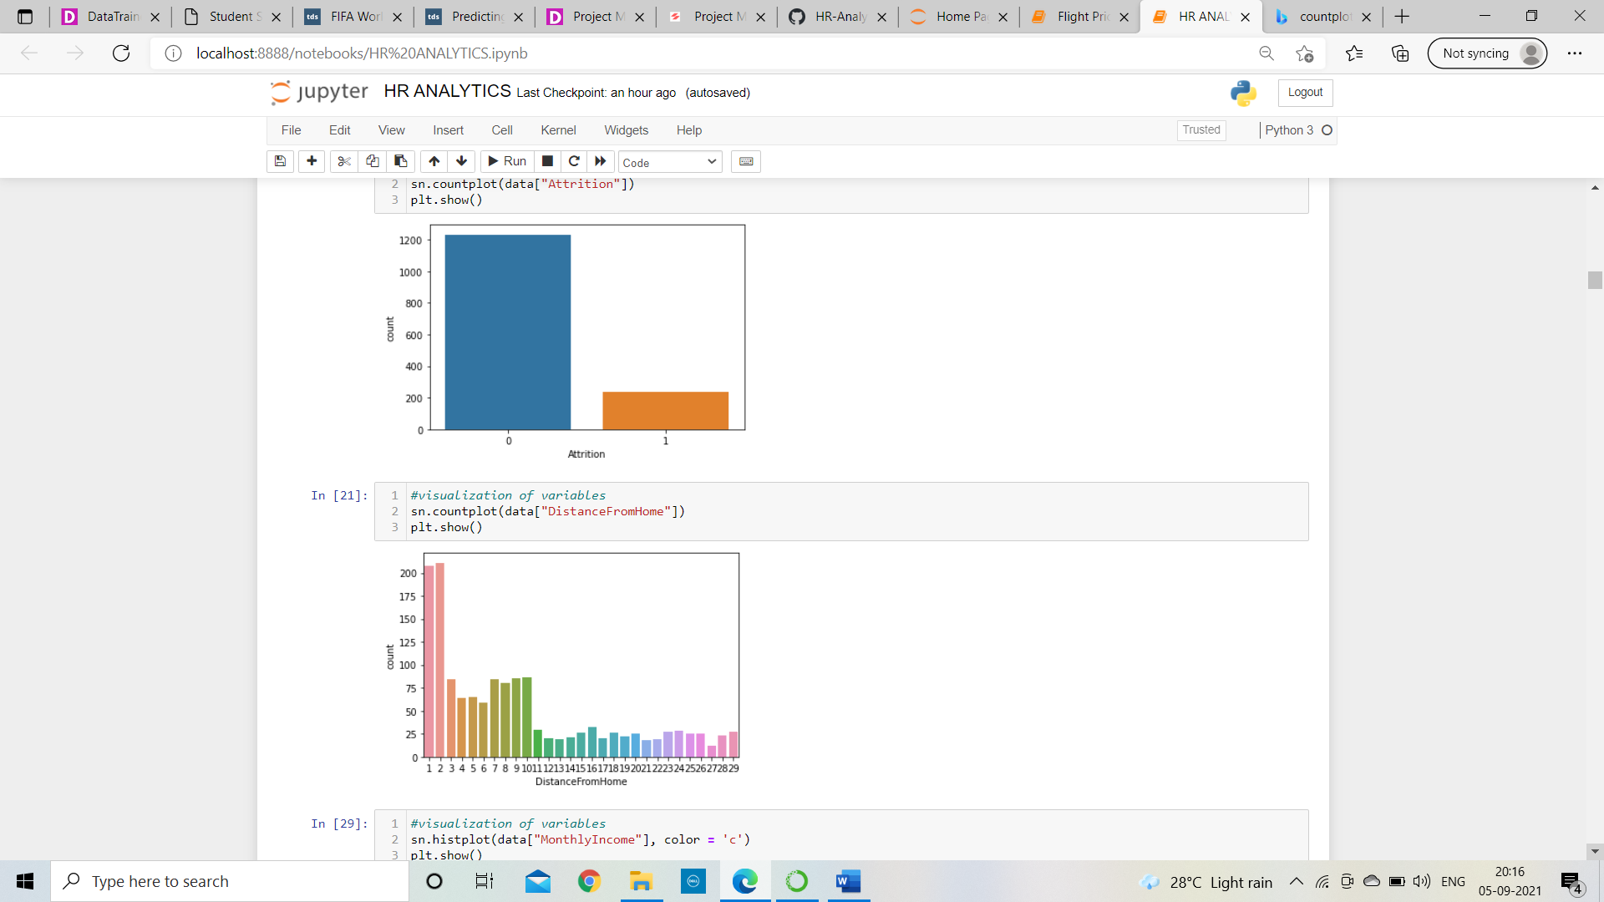

More than 50% of employees are against of attrition, which is good for any company and organization.



Majority of employees are staying in range of 0 to 2km with the peak at DistanceFromHome 2 kilometres.

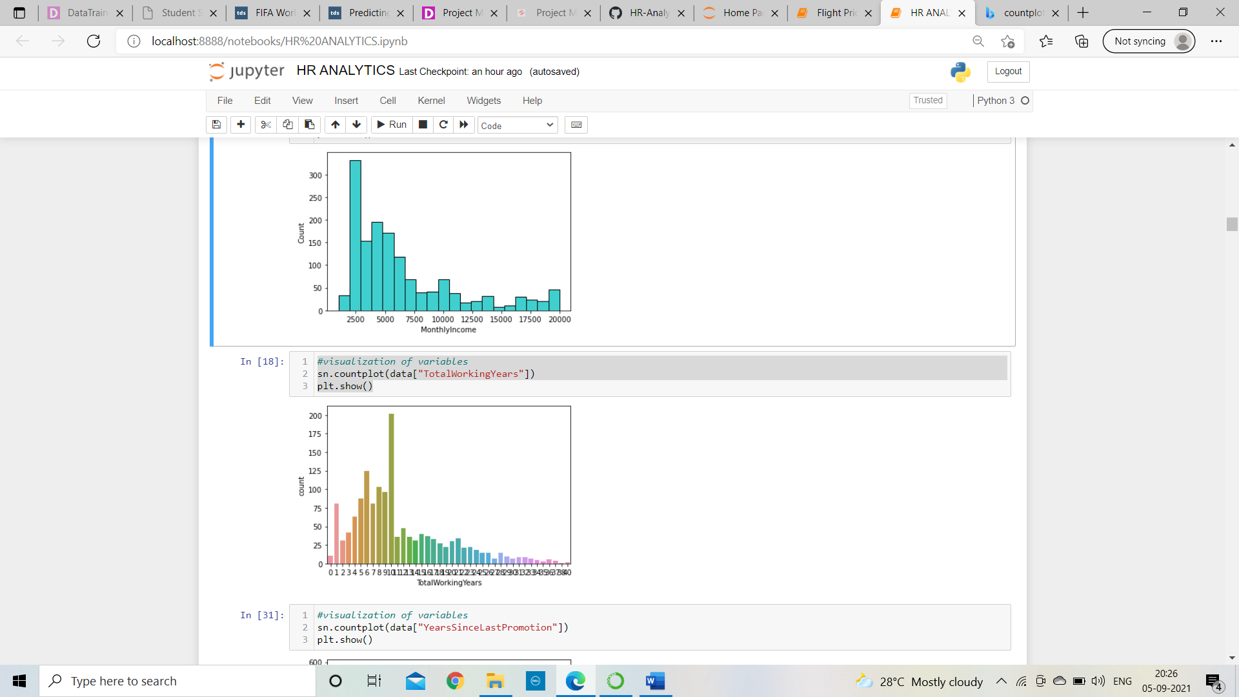

Extreme employees are having monthly income in between 2500 to 5000 with the peak at MonthlyIncome 2500.

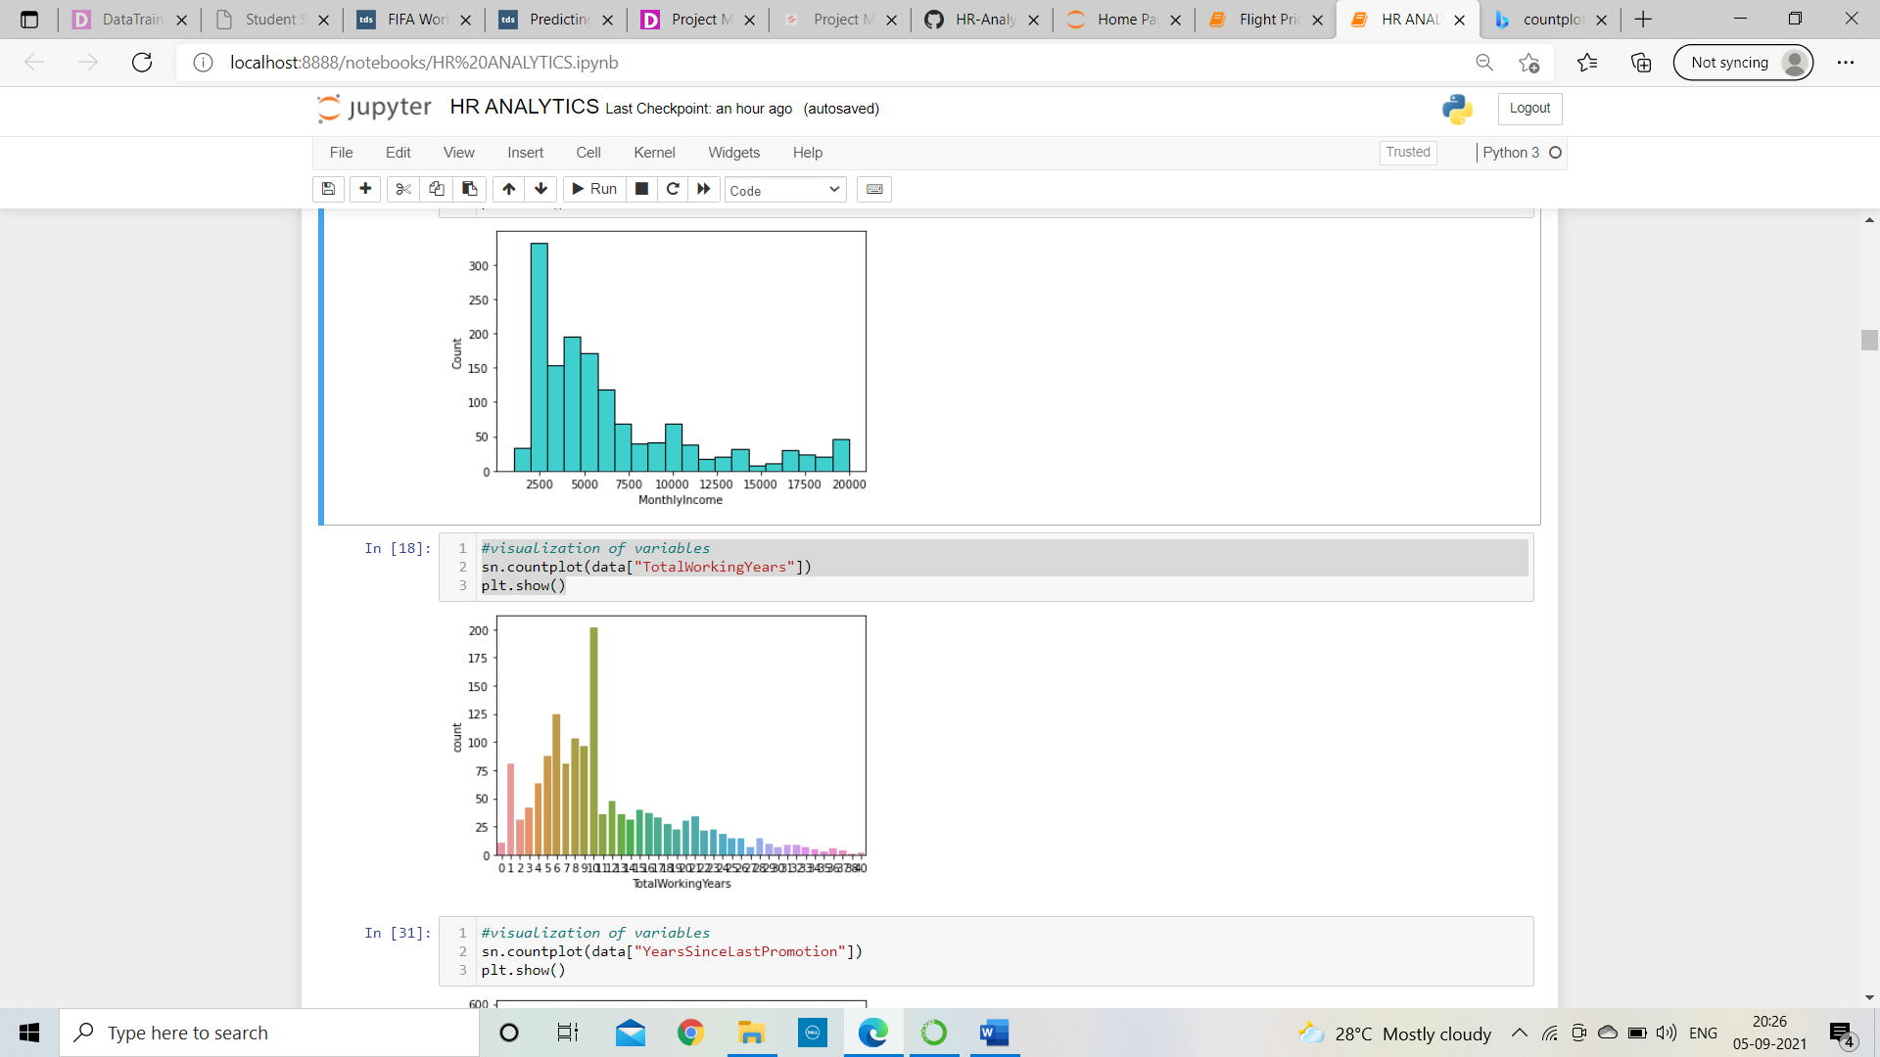

Total working years of maximum employees are in between range of 5years to 10years.

And many more things we can visualize through this countplots and one more thing we can found that skewness also present in some columns which need to remove.

**Multi variate analysis:**

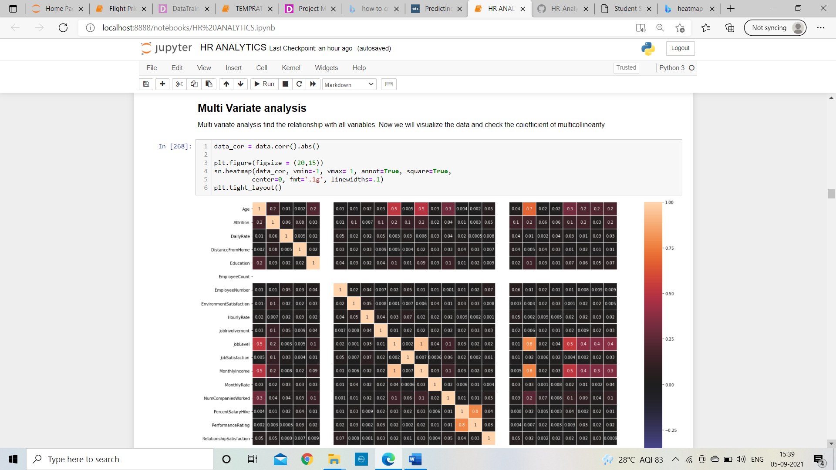

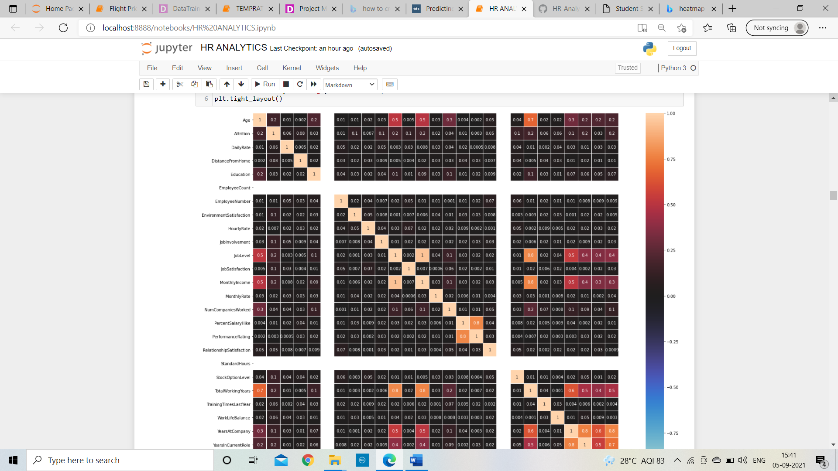

In Heatmap the values are represented in colours and it shows the correlation with each variable, as shown in above EmployeeCount and StandardHours are not having any correlation with any variables. So, these columns are not in use and we can delete that column from our dataset.

**Find out which columns are positively or negatively correlated with target variable:**

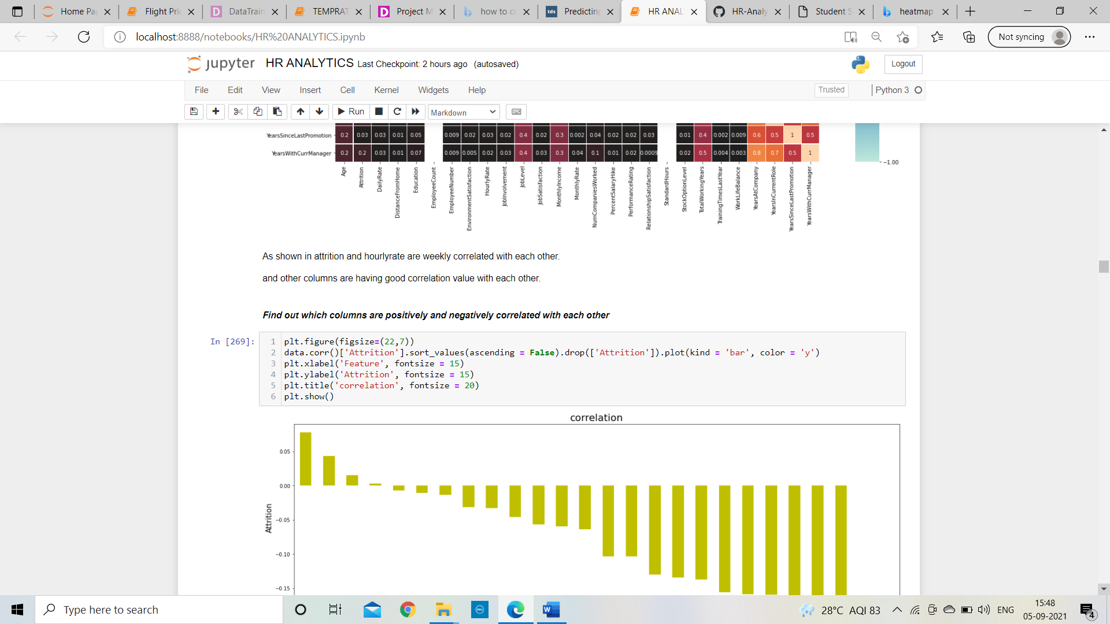

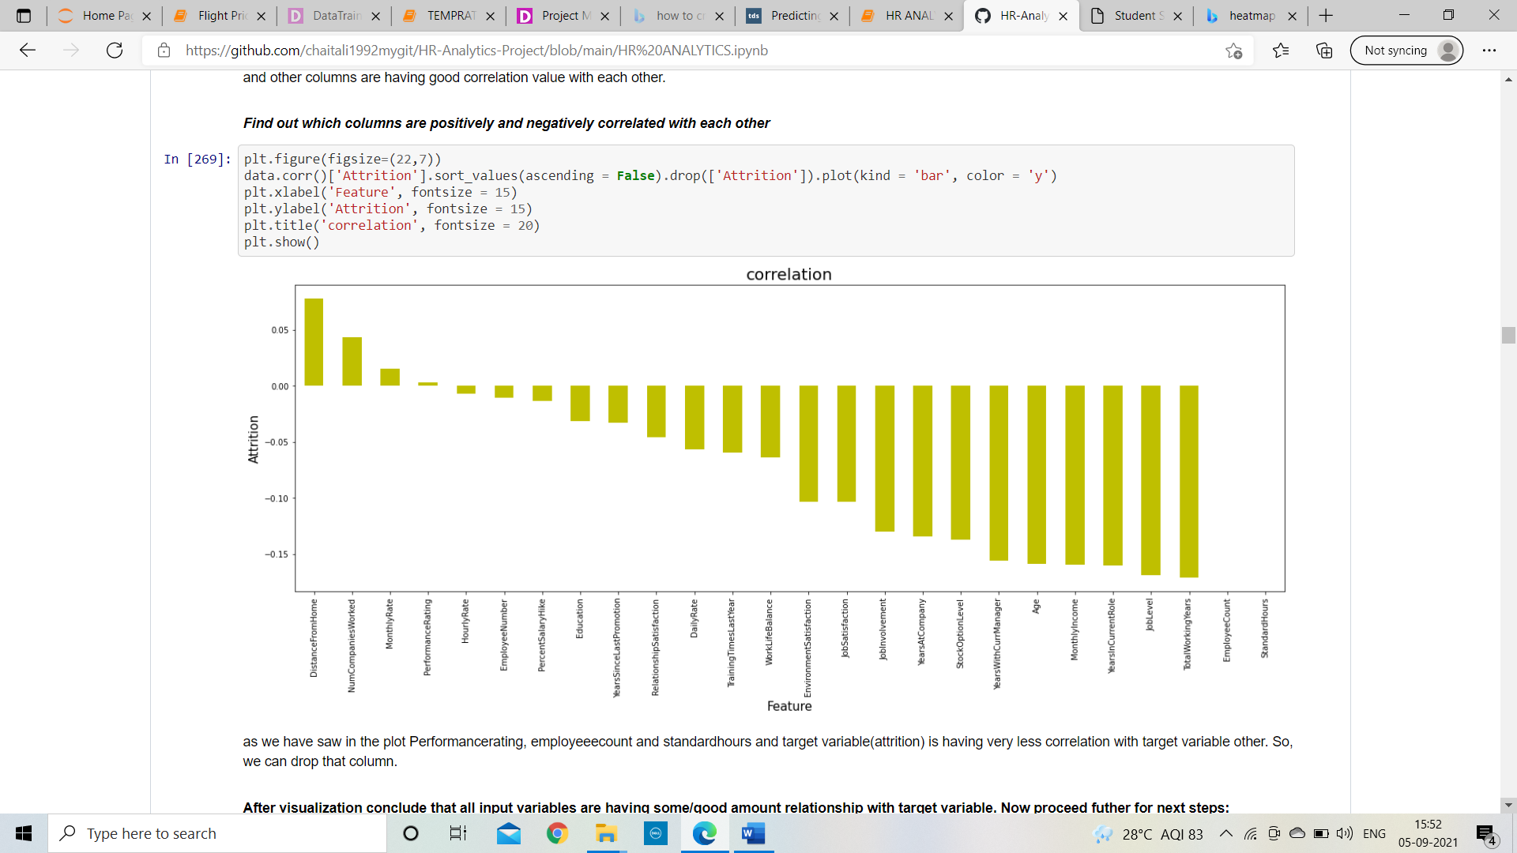

As shown in above we can see EmployeeCount and StandardHours are not having any corelation with target variable (Attrition). DistanceFromHome, NumCompaniesWorked, MonthlyRate, PerformanceRating are positively correlated with target variable and rest which shows in

Graph was negatively correlated with target variable.

**PRE-PROCESSING: -**

First, I will drop some input variables from the data set, because it does not contribute any valuable characteristics for model building and those variables are,

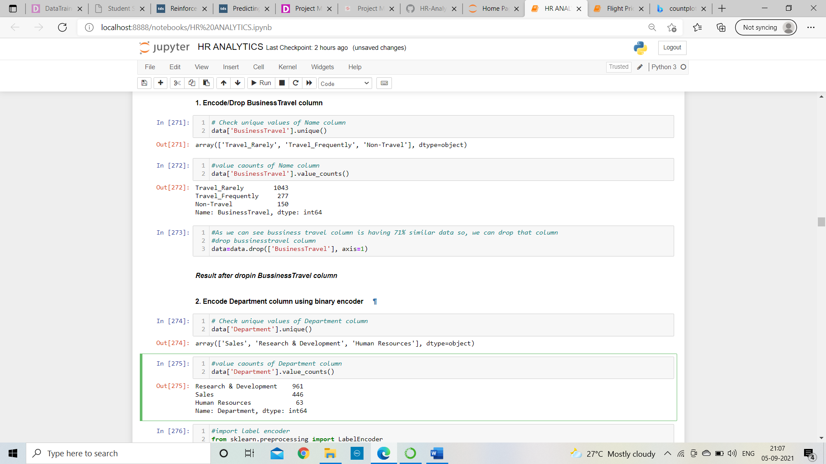

1. BusinessTravel: business travel column is having 71% similar data
2. Over18: All values of this column are same
3. HourlyRate: poor correlation with target variable
4. EmployeeCount: poor correlation with target variable
5. StandardHours: poor correlation with target variable
6. EmployeeNumber: All values of this column are same

After dropping these columns, I need to encode rest columns which are having object data type with the help of label encoder:

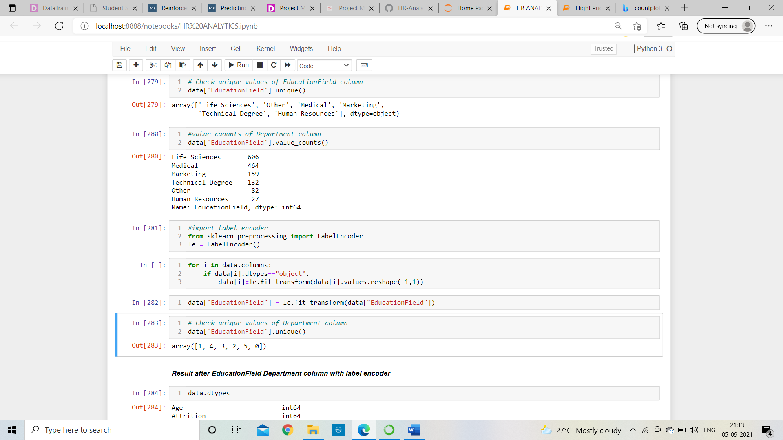

After encoding the dataset will look like;

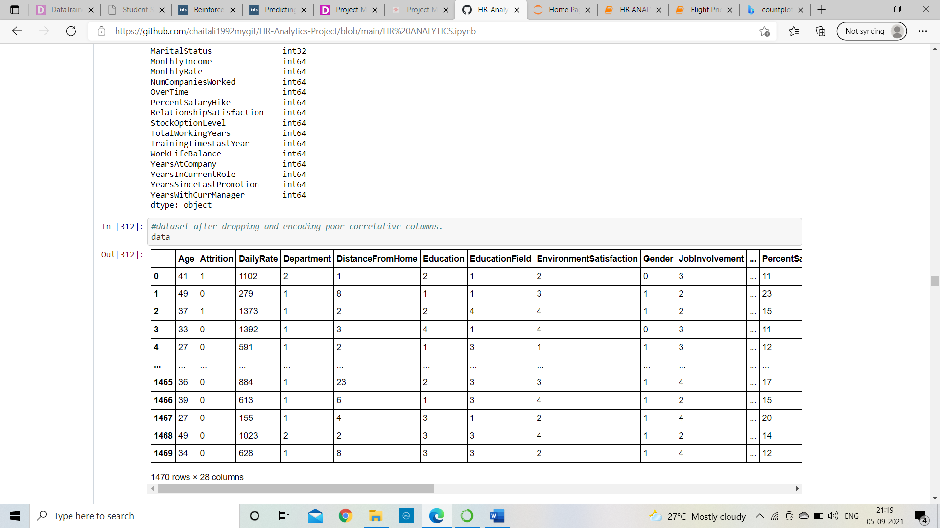

Now, I need to work on outliers. An **outlier** is a point that varies suggestively from the rest of the data. There are 2 types of outlier removal techniques are available and that are, first is Zscore Technique and second is IQR Technique.

1. Remove outliers using Zscore technique

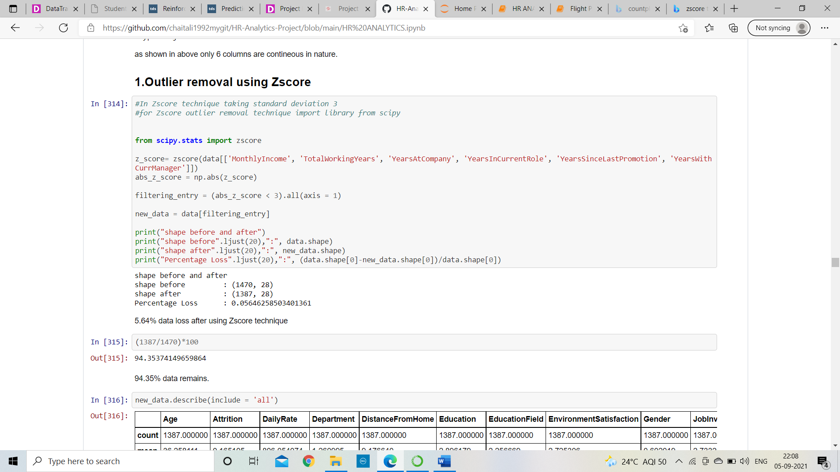

As shown above after applying zscore technique only 5.64% data will loss and 94.35% data remains in dataset. As zscore works with standard deviation 3.

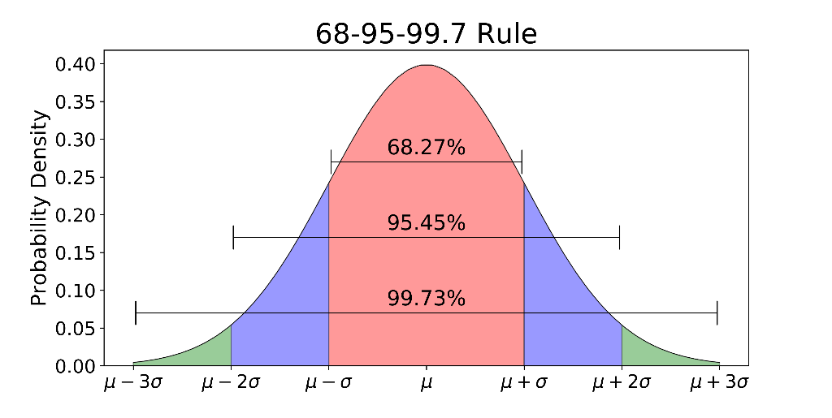

1. Remove outlier using IQR technique

In IQR technique the dataset is divided into four defined interval that are quartiles and compare the whole dataset.

IQR stands for Interquartile range which is the difference between q3 and q1

Q3 is 75% of particular column

Q1 is 25% of particular column

find the IQR (Inter Quantile Range) to identify outliers

Formula for finding IQR

* 1st quantile 25%

q1 = data.quantile(0.25)

* 3rd quantile 75%

q3 = data.quantile(0.75)

* QR = Inter Quantile Range

iqr = q3-q1

With the help of boxplot graph, we came to know that outliers present in particular columns and that column should be continuous in nature,

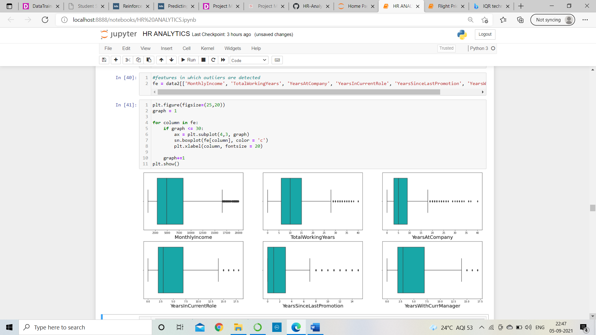



As shown in boxplot outliers presents in above columns

## **Outlier detection formula**

## Higher side ==> Q3 + (1.5 * IQR)

## Lower side ==> Q1 - (1.5 * IQR)

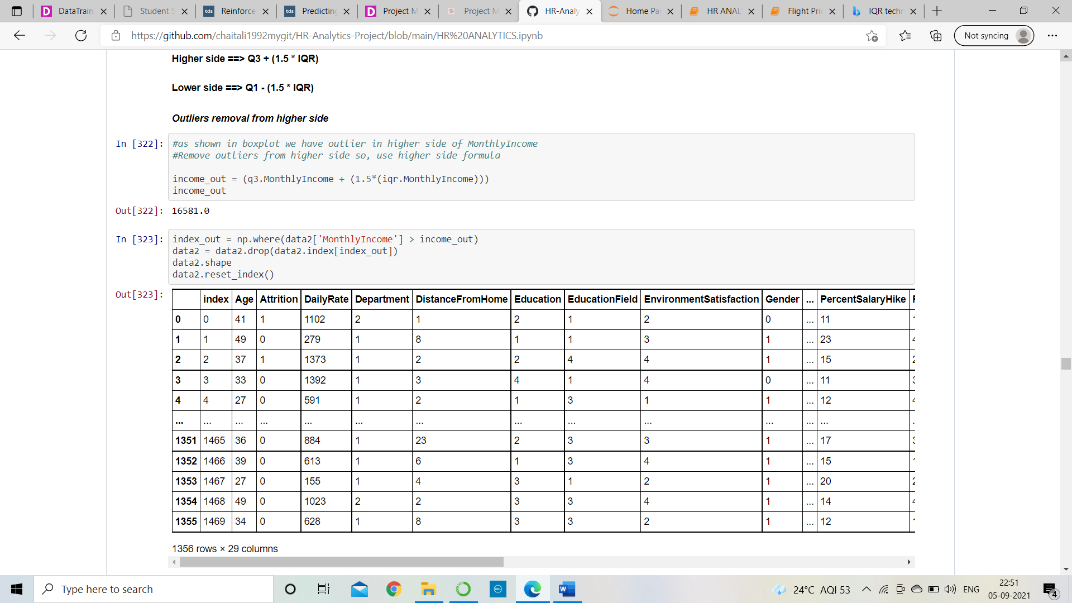

After applying it the dataset will be,

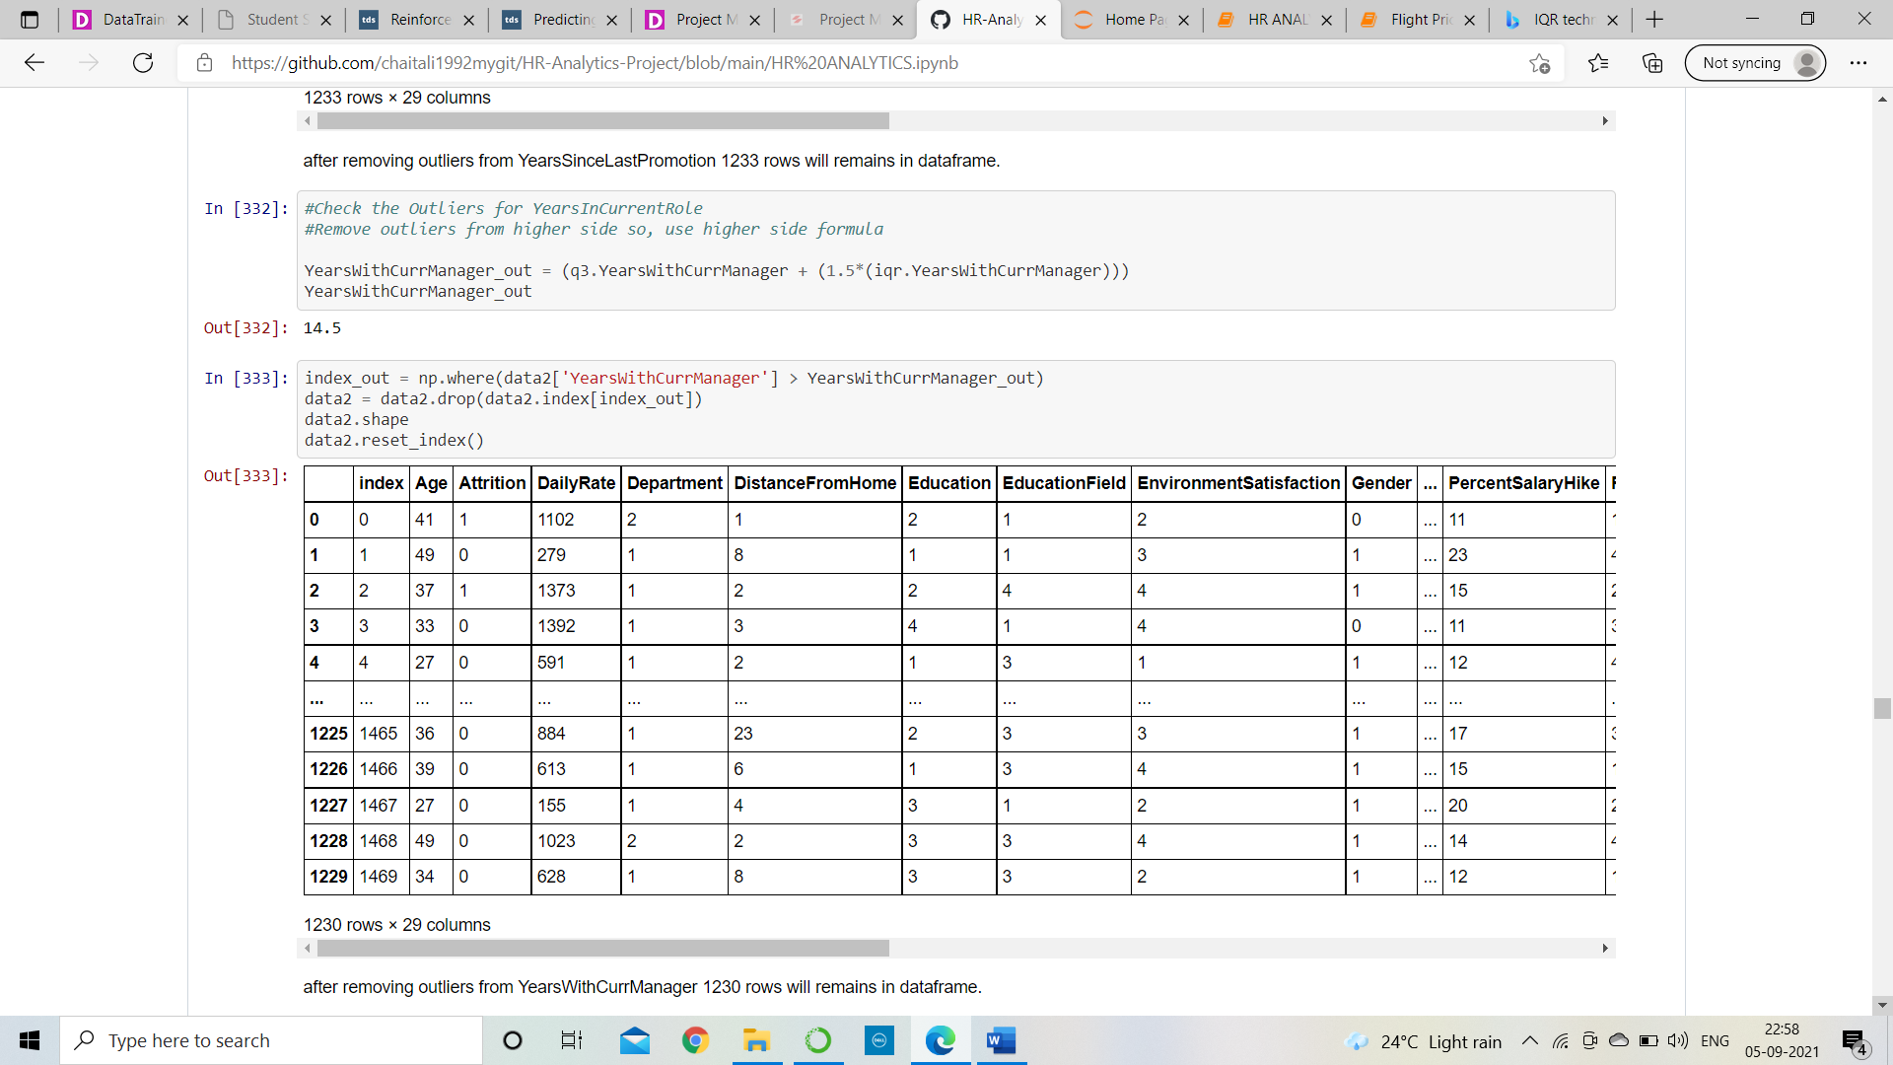

At the ending of IQR technique I can see at the bottom of table 1230 rows will remains in data frame which is very less as compare to zscore technique.

((1470-1230)/1470)*100 = 16.32%

16.32% data will loss in IQR technique.

We conclude that less amount data will loss in Zscore technique so we will go with Zscore technique.

**Check the skewness and remove that:**

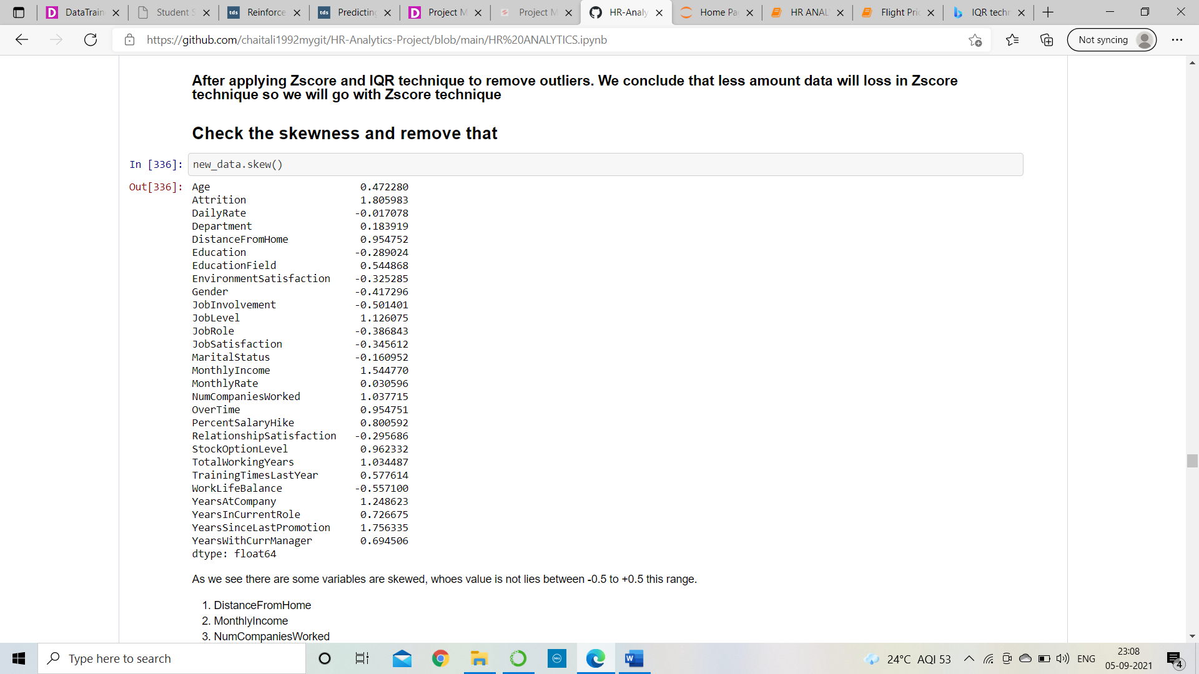



As we see there are some variables are skewed, whose value is not lies between -0.5 to +0.5 this range and that column should be continuous in nature and in this dataset maximum columns contains categorical values.

1. DistanceFromHome
2. MonthlyIncome
3. NumCompaniesWorked
4. PercentSalaryHike
5. TotalWorkingYears
6. YearsAtCompany
7. YearsInCurrentRole
8. YearsSinceLastPromotion
9. YearsWithCurrManager

**Apply Log transformation to remove skewness:**

In log transformation, we will take the log of Continues skewed data and convert that into normal data(distribution)/less skewed data

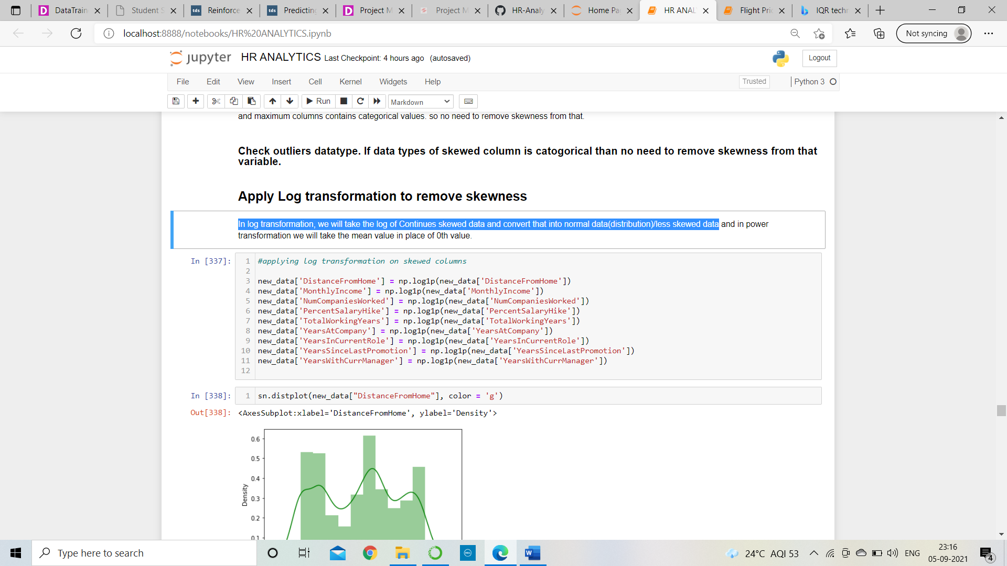

After applying log transformation skewness will remove, which shows in table below, in that the value does not lies between -/+5.

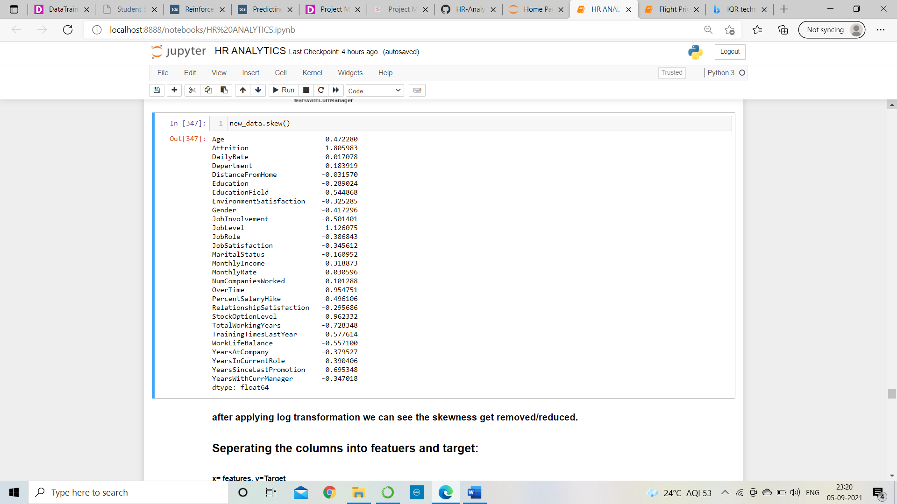

Visualize the data columns after applying log transformation.

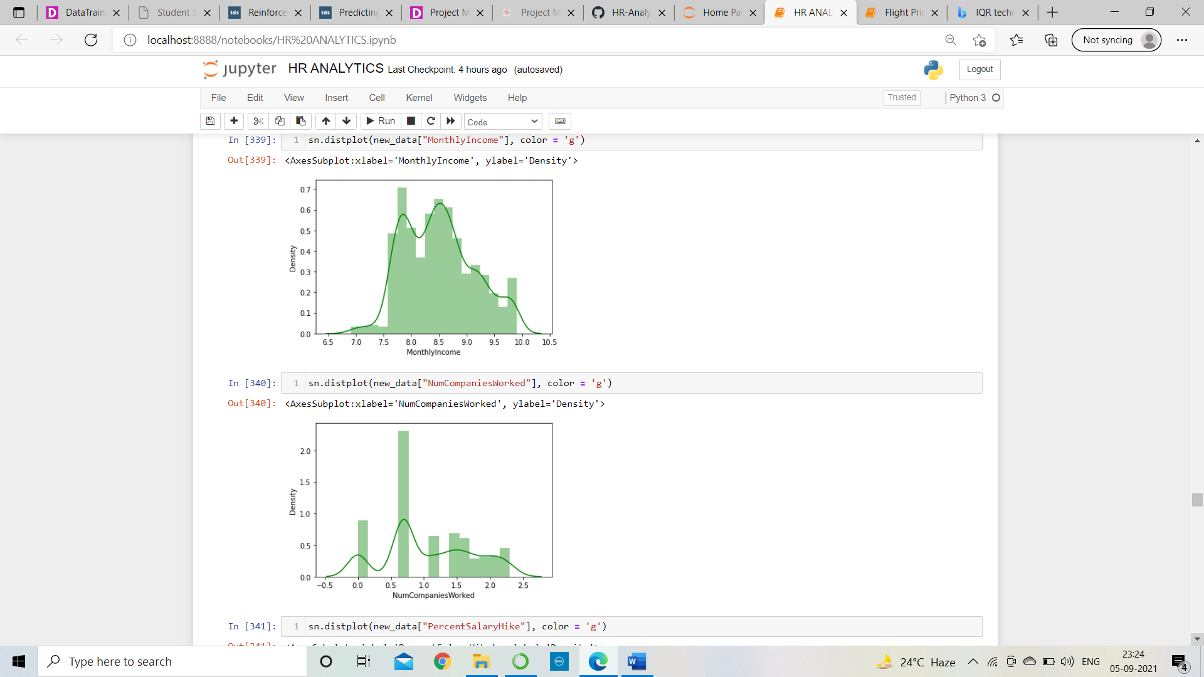

after applying log transformation, we can see the skewness get removed/reduced. Now safe to proceed further.

**Separating the columns into features and target:**

x= features, y=Target

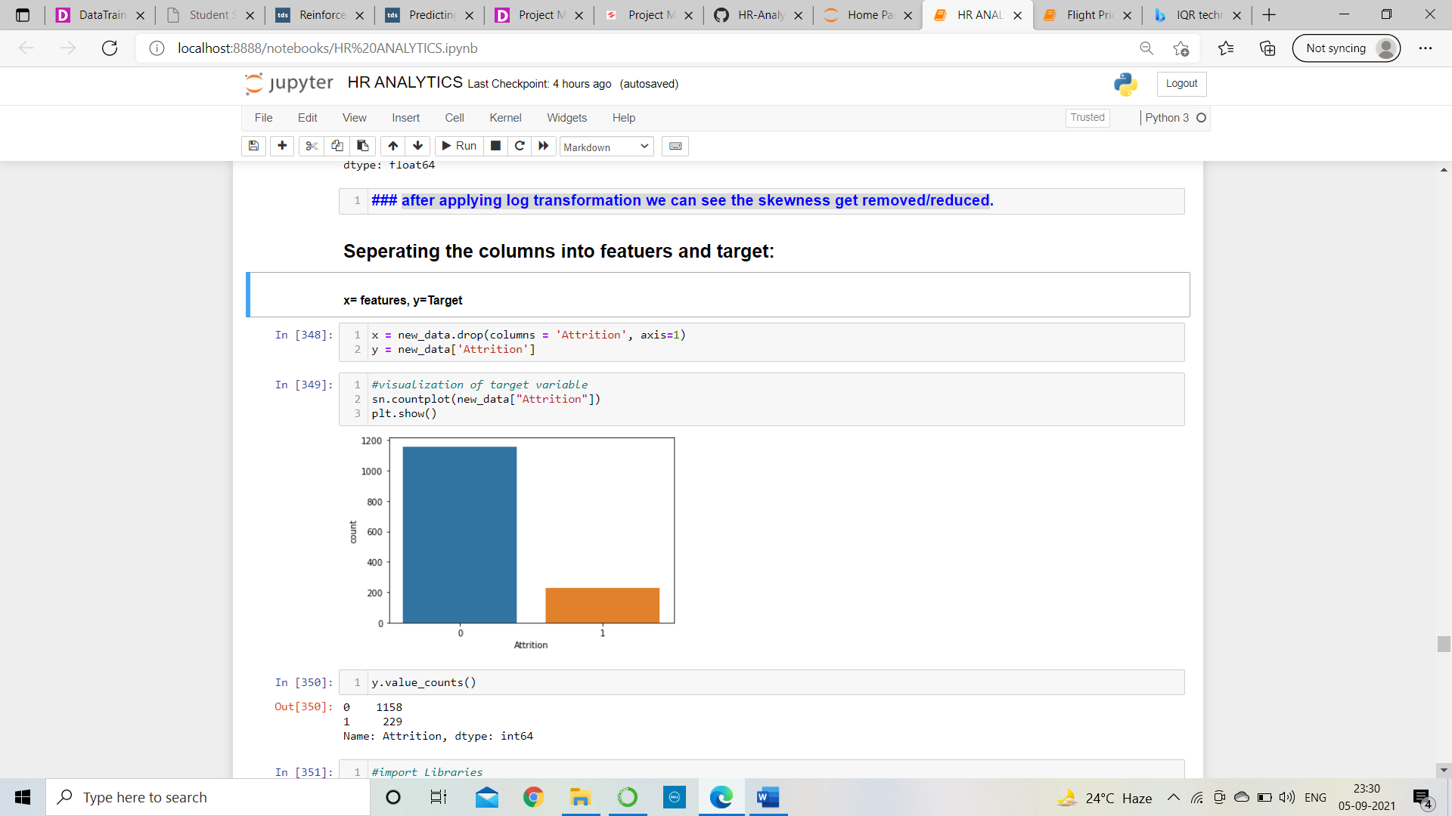

**Sampling:**

As we see in target variable, I am facing the class imbalance issue and if I will go with that same data than my model will get biased and accuracy score will not accurate, so first I need to the sampling of target variable and make them balanced with the help of Oversampling but before that I need to do scaling on independent variable to improve accuracy.

**Scaling:**

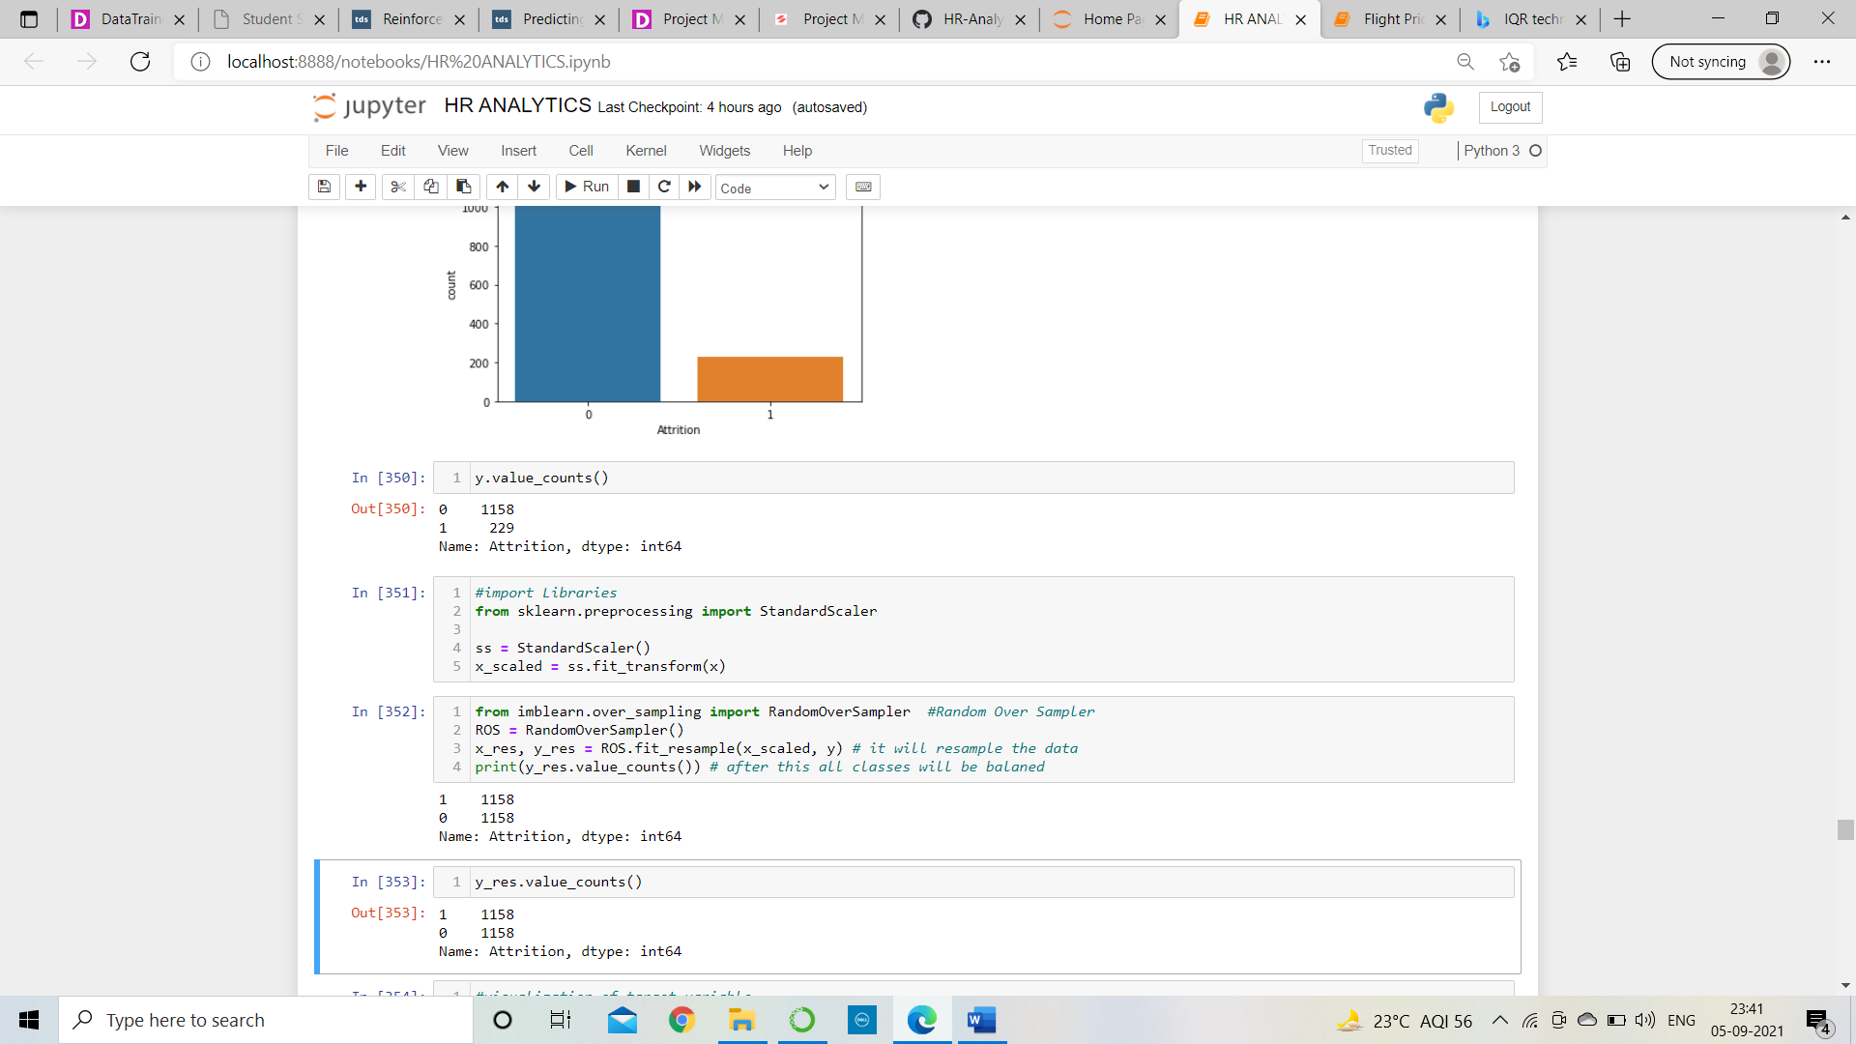

The values of input variable are scaled. Now, work on sampling,



As we see above the values of target variable is balanced now.

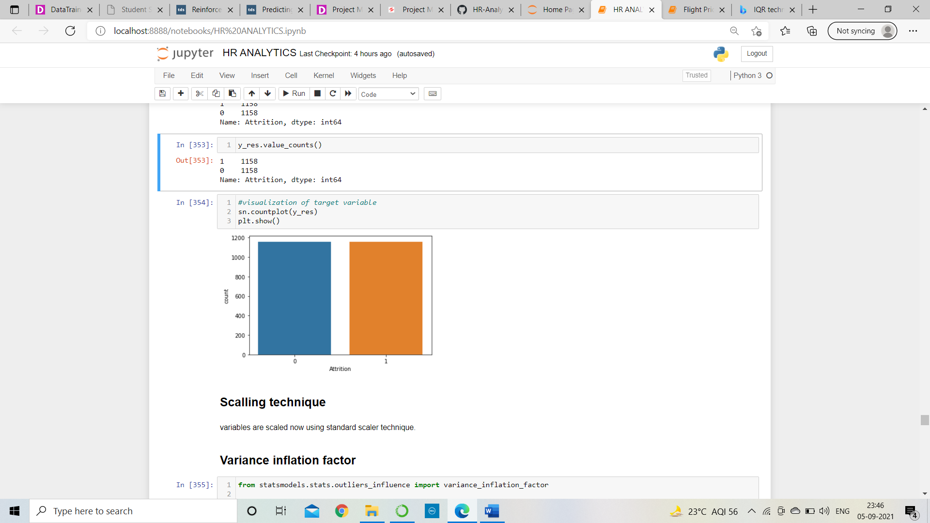

**Variance inflation factor:**

Variance inflation factor is